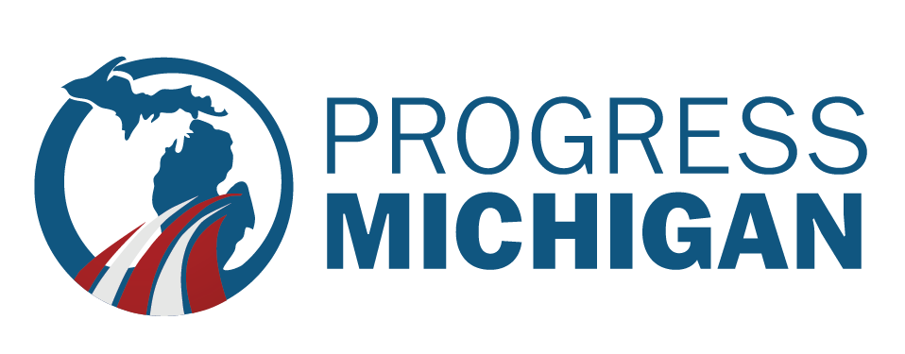

Health Leaders Media Training Agenda 2020

10:00 a.m.: Introduction, Agenda, Questions from Webinar
10:15 a.m.: Elevator Pitch– Small Group Reviews
10:40 a.m.: Interview Strategies and Best Practices
11:15 a.m.: Break
12:00 p.m.: Practice Interviews – Small Group (TV and radio)
1:00 p.m.: Practice Interview Debrief
1:15 p.m.: Q&A, Wrap-up, Evaluation

